Octopus Music API: Basic Classes
The Octopus Music Library is a Java API designed to help developers and composers to deal with musical elements in a high level programming environment.
Differently from other APIs’ for music software development, the Octopus API has its focus on the modelling of musical performance elements, mainly the performer and his instrument. A possible use of this API is on the recreation of a musical performance for a particular performer in a particular musical instrument. For example, how a guitarist plays I IV7 V harmonic progression in 12-string guitar tuned in E Major? With the library is possible answer this question and goes beyond, also calculating the best way to play the chords (chord shapes) and the right arpeggio for them.
The API is organized in a top-down hierarchy scheme, meaning that the classes in sub packages have a dependency with the bottom ones. The packages are physically organized as follow:
Package octopus: The classes in this package represent general musical concepts.
Package octopus.instrument: Specialize the classes on the octopus to an instrumental context. The classes placed in this level must be generic enough to allow the expansion of the API to new instruments.
Package octopus.instrument.string: Specify the classes on the octopus.instrument to a level of the string instruments;
Package octopus.instrument.string.fretted: Specify the classes on the octopus.instrument.fretted to a level of the fretted instruments, normally from the luto family.
Package octopus.communication: Middle-tier abstract communication protocol to external devices in charge to render the sound.

Package octopus.communication.midi: Classes that parses the octopus.communication classes to MIDI protocol messages.
Package octopus.util: Miscellaneous utility classes;
Conceptually the classes are classified in:
- Musical data structures classes (playable): Classes that represent musical concepts which are understandable by musicians and can be rendered into sound;
- Musical data interpretation classes (musicians): classes that can be parse the playable classes into sound;
- Instrument Classes: Definition of the instrument by its playability.
- Communication classes: Bridge between the musical data interpretation classes and the sound generator devices;

This document is a small description of the Octopus API that aims to explain some of the main classes of the system.

Musical Data Structures
This classification refers to the computational formalization of musical concepts. This classification is applied for classes that represent musical concepts, such as note or rhythm pattern. Although some of classes extend the original musical concept, they are all somehow musically interpretable.

Basic Musical Structures

Class octopus.Note
Note is the smallest musical element implemented in the API. Although is possible instantiate Note objects, this practise in not recommended. Instead, the notes can be obtained through the NoteFactory static class. This strategy was conceived having in mind that a 1one note by itself is not very meaningful if compared to a contextualized note in a scale or melody, for instance.
Through the NoteFactory, it is possible obtain notes in different ways, measure distance between notes and perform other computations over note objects. I.e. Both methods returns a the A note: NoteFactory.getA( ) and NoteFactory.getNote("A");

The notes attributes are:
- Name; (C Sharp or Dó Sustenido)
- Symbol; i.e. C#
- Pitch Value; i.e. 64 (midi)
- Octave Pitch, i.e. C4.
- Accidents (sharp, double sharp, flat, double flat)

Class octopus.Chord
A chord is a set of notes that can be played together or arppegiated. In this API the notes that compose a chord are encapsulate in ChordNote objects. A ChordNote is a note with contextual information, meaning that the note knows its role (interval) in the chord context.
There are different ways to create a chord object but the main one is based on the chord musical notation. The chord musical notation can be seen as a language to describe chords with a well defined semantic and syntax. The API, just like a complier, runs a lexical analysis over the inputted text representing the chord and validates or refuses it based on the alphabet in use (ChordNotation). Unfortunately, the chord notation is not standardized all over the world meaning that the chord written names (symbols) might vary among different communities (nationalities, musical style, instrument etc.). The default chord notation is based on Brazilian Bossa Nova known by its complex harmonies.

Chord chord = new Chord(“C#m7(add11)”);
Code example 1: Chord objects instantiation.

Te instantiated chord in the Code example 1 has the ChordNote’s objects described in Table 1.
Table 1: Chord's note
Index | Interval | Note
0 | Fundamental(root) | Note C#
1 | Minor 3rd | Note E
2 | Perfect 5th | Note G#
3 | Minor 7th | Note B
4 | Major 11th | Note F#

Two additional pointers are used indicate the root and the bass notes, which are not the same note in the inversion cases. In the example given, both pointers are on index 0.
If the default chord notation is not adequate, than it is necessary to load another ChordNotation (stored in a file) into the ChordNotationInterpreter and generate a ValidChordName object. This object can be used as an argument in the Chord’s constructor.

Rhythmic Classes
In the Octopus Music API the rhythmic line is defined independently from the melody or harmony facilitating the manipulation on either notes or rhythmic data.
To facilitate and turn the programming more intuitive and readable all rhythmic values (duration, accent dynamic, rhythm event type) are defined in RhythmConstant interface, which is realized by all rhythm classes;

Class octopus.Bar
A bar represents a simple rhythmic phrase. It’s a collection of the smallest rhythmic structure designed in the API, the Bar.RhythmEvent.
A Bar.RhythmEvent can be a note or rest defined by the type attribute. The duration attribute is necessary applied in both case, but the dynamic only makes sense if the rhythm event is a note. If it is necessary link the note’s duration with the next note’s duration in the sequence (legato) than the tie attribute need to be set true.
The accent is an emphasis placed on a particular note of the bar, in our case in a particular Bar.RhythmEvent. This accentuation array can be informed to the Bar for a customized dynamic and expression, or a default value will be used. In the current version, a half strong accentuation is the value.
The accentuation value is a number between 0 and 1 relative (percentage value) to the dynamic of the note, and is given by the constants: ACCENT_STRONG = 1.0, ACCENT_HALF_STRONG = 0.5, ACCENT_WEEK = 0.25.
The dynamic of the notes are given by the constants:
DYNAMIC_PIANISSIMO = 0.1;
DYNAMIC_PIANO = 0.2;
DYNAMIC_FORTE = 0.8;
DYNAMIC_MEZZO_PIANO = 0.4;
DYNAMIC_MEZZO_FORTE = 0.6;
DYNAMIC_FORTISSIMO = 1.0;

The time signature of the bar is written in form of fraction given by number of rhythmic units divided by the measuring of the unit. Considering the purpose of an API, the Bar will not block the input of rhythmic events that exceeds the time signature, instead, the bar.getSignatureDistance( ) method was implemented to inform the programmer if the rhythmEvents are adequate to the metre or not.
Figure 1 shows the internal structure of the Bar and an example.
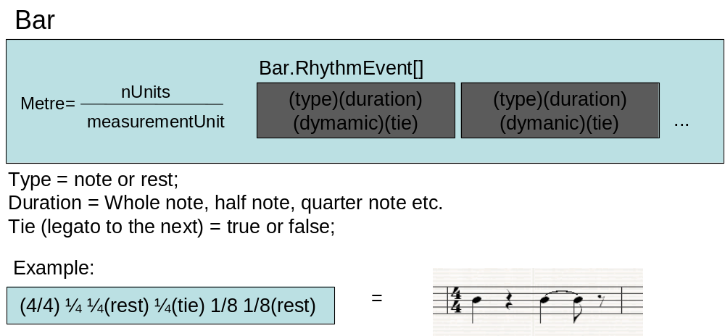
Figure 1: Bar internal structure
The organization of the rhythmic events according to the metre is pretty straight forward except in the tuplet’s case. The tuplet allow the organization of two of more rhythmic events in a time frame (duration) smaller than the total duration of the events in the tuplet. The Code example 2 shows an example of tuplet definition illustrated by Figure 2
Bar bar = new Bar(2,4);

bar.addRhythmEvent(bM.QUARTER,1);
double[ ] tupletDurations = {BAR.EIGHT_NOTE , BAR.EIGHT_NOTE, BAR.EIGHT_NOTE };
int[ ] tupletNoteTypes = {1 ,0,1 };
boolean isTie = true ;
bar.addRhythmEvent(durations, types, bar.QUARTER_NOTE, isTie);

bar.addRhythmEvent(bar. SIXTEENTH_NOTE, Bar.INPUT_NOTE);
bar.addRhythmEvent(Bar.getDottedValue(bar.EIGHT_NOTE), Bar.INPUT_REST);

Code example 2: Bar definition

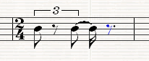
Figure 2: Equivalent Bar of Code example 2

Class octopus.RhythmPattern
The RhythmPattern represent a monophonic rhythmic line on either melody or harmony. In the melody case, the rhythm pattern is mapped to the notes while in the harmony it is mapped to the chords. If the chords’ notes need to be treated independently (different start time and/or duration) then the Arpeggio class must be used, as explained latter on. Once again note that in this API the rhythmic line is defined independently from the notes.
A Rhythm Pattern is composed by bars (in sequence), marks and returning points to these marks. The bars are inserted sequentially so the input order is relevant.
The repetition mechanism is composed by two parts: a mark and a repetition point. The mark is placed like a bar in a certain position of the rhythm pattern. Every time that a return point is reached, the pointer goes back to the mark pointed by it. This loop lasts while the number of repetitions specified in the return point is not achieved. The mark is addressed by its name. Figure 3 shows an example of a returning point placed after the 3rd bar that goes back to Mark M1(after 1st bar) 3 times.

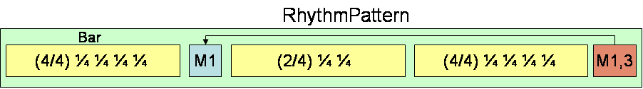
Figure 3: RythmPattern structure example.
The Code example 3 shows the RhythmPattern illustrated by Figure 3. Note that the input order of the elements in the RhythmPattern is absolutely relevant.

RhythmPattern rhythmpattern = new RhythmPattern();
Bar bar1 = new Bar(4,4);
bar1.addRhythmEvent(Bar.QUARTER_NOTE,1);
bar1.addRhythmEvent(Bar.QUARTER_NOTE,1);
bar1.addRhythmEvent(Bar.QUARTER_NOTE,1);
bar1.addRhythmEvent(Bar.QUARTER_NOTE,1);
Bar bar2 = new Bar(2,4);
bar2.addRhythmEvent(Bar.QUARTER_NOTE,1);
bar2.addRhythmEvent(Bar.QUARTER_NOTE,1);
Bar bar3 = new Bar(4,4);
bar3.addRhythmEvent(Bar.QUARTER_NOTE,1);
bar3.addRhythmEvent(Bar.QUARTER_NOTE,1);
bar3.addRhythmEvent(Bar.QUARTER_NOTE,1);
bar3.addRhythmEvent(Bar.QUARTER_NOTE,1);

//placing the bar and setting the return point
rhythmpattern.insertBar(bar1);
rhythmpattern.insertMark("M1");
rhythmpattern.insertBar(bar2);
rhythmpattern.insertBar(bar3);
rhythmpattern.insertReturn("M1",3);

Code example 3: RhythmPattern definition

Class octopus.Arpeggio
An Arpeggio is a set of RhythmPattern played simultaneously, each one linked to chord’s note (voice). It is used to distribute the chord’s notes along the chord’s duration. Rarely the arpeggio information is written on in the score and its use varies upon to the performer’s technique and expressivity.
The rhythm patterns that compose the arpeggio, named voices, are vertically organized into the Arpeggio as can been seem in Figure 4. The lowest voice index (zero) will be linked to lowest pitch note of a chord, the second lower to the second lower pitch voice and so on.

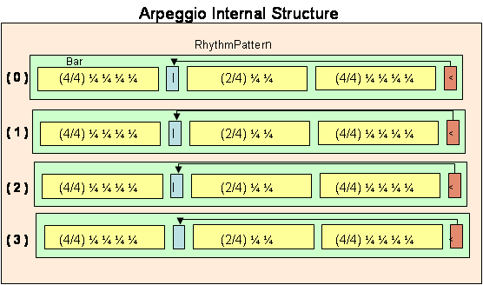
Figure 4 :Class Arpeggio data structure

An arpeggio must be simple as possible. Complex arpeggios can be created merging simple ones. This way, the complexity will be broken and the coding facilitated.
An arpeggio can be seen as a matrix of Bar.RhythmEvents that is the smallest element of a rhythmic line. These rhythm events are organized into bars (Class Bar), and the bars organized into rhythm patterns. When a Musician is requested to play a Harmony using an Arpeggio, he will adapt the arpeggio to the RhythmPattern of the Harmony, repeating or stretching the Arpeggio to the respective Bar.RhythmEvent’s duration written in the RhythmPattern. Note that the same arpeggio can be applied to different chords and its duration will vary upon the respective rhythm event linked to that chord. This feature is called time stretching and can be modified through the setTimeStretch(boolean) method (default value is true). If the time stretching feature is disabled, the arpeggio will repeat itself until reach the chord’s duration, trimming the event’s that exceed this limit. Figure 5 illustrates the time stretching computation over the arpeggio linked to the C chord.

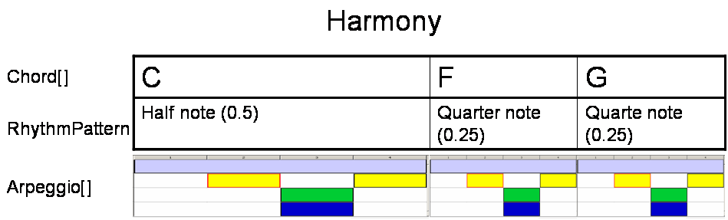
Figure 5: Arpeggio tempo adjusting to the harmony rhythm pattern

The Code example 4 shows how to create an arpeggio object. This arpeggio has 4 voices, each voice (RhythmPattern) with one 4/8 Bar. An equivalent CMN score representation can be seem in Figure 6.
public void getArpeggio getArpeggio(){
Arpeggio arpeggio = new Arpeggio(4);
gpr.setName("Fast Arpeggio");
Bar[] bars = new Bar[4];
for(int i = 0; I < 4; i++){
bars[i] = new Bar(4,8);
bars[i].addSingleRhythmEvent(Bar.EIGHT_NOTE,Bar.NOTE,i);
arpeggio.insertBar(bars[i], i);
}
return arpeggio;
}

Code example 4: Arpeggio definition
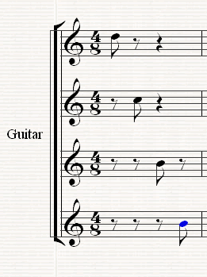
Figure 6: Score representation of Example 1

Musical Components
Music is normally expressed in terms of pitch (which includes melody and harmony), rhythm (which includes tempo and meter), and the quality of sound (which includes timbre, articulation, dynamics, and texture).This API models as these components apart from those considered the to be the responsibility of the sound generator unit, like the timber and texture. This API aims to be a bridge between the musical software and the sound generator units, like synthesizer or samplers.

In the context of this API, the musical components (MusicalComponent) are the objects that can be arranged along the time in order to be played as a single unit known as Music. These components can be either a Melody or a Harmony. Remember that both are linked to their own rhythmic pattern, so the abstract class MusicalComponent implements methods to deal with the rhythmic data. E.g. getDuration( );
Up to this point the rhythm pattern has priority over melody and harmony. A higher priority means that the rhythm pattern will repeat the notes (melody) or chords (harmony) until the end of rhythmic pattern. This may change in future versions to a more flexible approach.

Class octopus.Melody
Melody is a set of notes disposed in a sequence and played according to a certain rhythm pattern. Like the RhythmPattern, melody is monophonic.

RhythmPattern rp = RhythmPatternLibrary.getConstantRhythmPattern();
String[] notes = {"C", "E", "F", "G", "F", "C","C", "E", "F", "G", "F", "C"};
Melody melody = new Melody(notes,rp);

Code example 5: Melody definition
The Error: Reference source not found creates a simple melody with the notes specified in the notes’ array (line 2).

Class octopus.Harmony
In the context of the Octopus API, harmony is a set of chords played according to a RhythmPattern and Arpeggio.
The duration of each chord is the same as the rhythmic event associated with it, as previously illustrated by Figure 5. This means that the player move through the chords following the rhythm event time.
The notes of the chords are played according the arpeggio assigned to it. Each chord can be played with a different arpeggio. If an arpeggio is not assigned for a chord then all notes of the chord will sound simultaneously and lasts for the chord’s duration.
There is no information on the Harmony class defining how the chords must be played (i.e chord’s shapes). This knowledge belongs to the Musician.

Class octopus.Music
Music is a set of MusicalComponents organized in time. The music’s timeline is represented by the Music.Timeline Class which is responsible to index musical components (Harmony or Melody) along in the time, expressed in musical terms. This means that all the time information in the system is based on the duration of the notes. This means: in the API a whole note has duration of 1.0 relative time unit. This simplifies the time’s notation in the API, since you don’t need to convert to ticks or any other non-musical reference.
Figure 7 shows an example of a music composed with 3 harmonies and 3 melodies. Note that H1 and M3 start in the beginning of the music, so the index 0 of the timeline points to both objects. That’s not happen in H2 or M1 that start in random position in time and have an exclusive pointer in the timeline table.

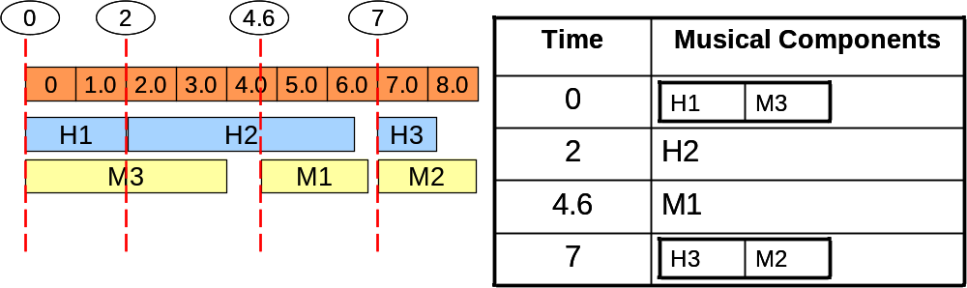
Figure 7: Internal musical components organization over the time

Musical Data Interpreters
As previously mention, the Octopus Music API has its focus on the modelling of elements involved in a musical performance, mainly the performer and his instrument. This interaction between performer and instrument is unique and can happen in different levels. As visualized in Figure 8.
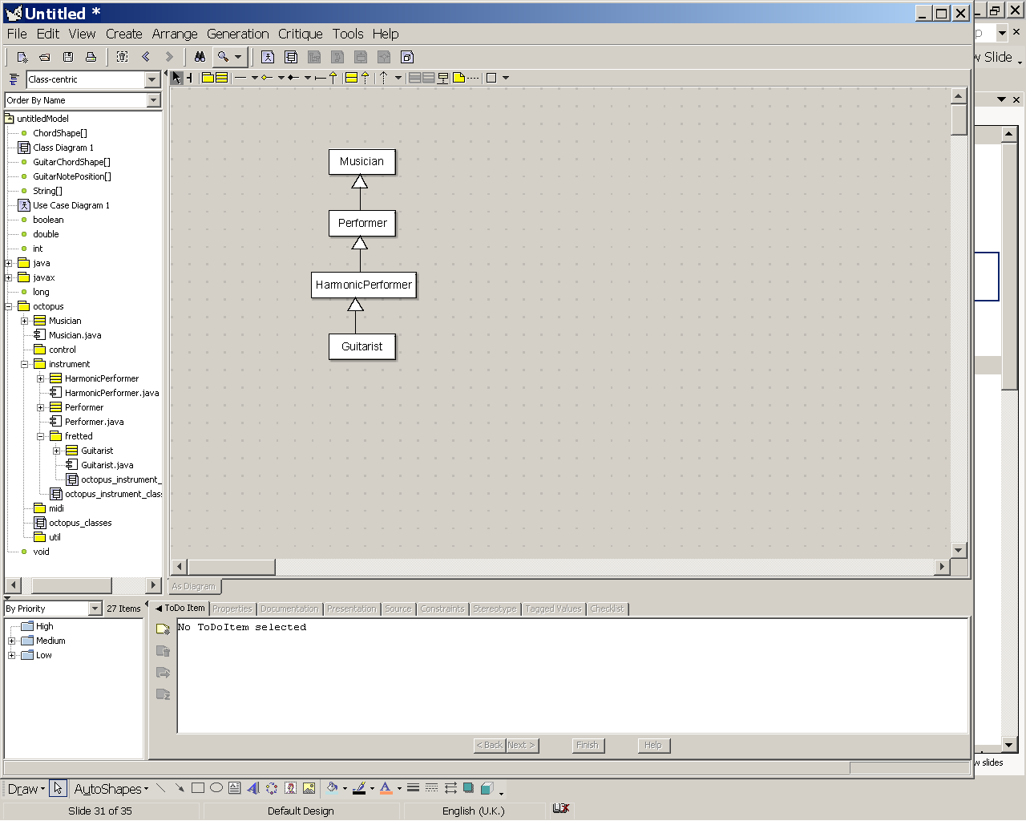
The interpretation of the musical information varies according to the knowledge of the musician and context where it has been applied. The first and most basic level of interpretation is the Musician that only has musical knowledge but doesn’t know how to play an instrument.
Figure 8: Musician hierarchy

Class octopus.Musician
The Musician is basically an interpreter of the playable musical structures like: scales, melody, harmony, music, rhythm pattern and so on. The musician knows how to read and play these structures in the most basic way as possible. No instrument restriction is considered in this computation.
A technical note: the musician does not need to know MIDI, OSC or any other communication protocol. This is not his role. His role is related only with the understanding of musical information, mostly related to notes and time. However, to output this musical information, he needs to make use of a sound generator device, like synthesizer. Consequently, he needs to control this device somehow. For this purpose, the music communication package was created.
By now, its only important remind that, basically, a musician parses the musical information to a middle-tier protocol that later on can be converted to the protocol support by the available synthesiser.

Class octopus.instument.Performer
Performers are musicians that know how to play a musical instrument. So besides the musicians knowledge, their also have particular knowledge of a musical instrument. Since Performer is an abstract class, it needs to be specialized for a particular instrument.
All performers are able to play PerformableMelody, which is a melody with performance information. A performer that is able to play harmony is a HarmonicPerformer. A HarmonicPerformer is able to play ChordShapes and PerformableHarmony. As musician, they are still able to play simple Harmony and Melody, to do so they adapt these musical components to the limitations to his instrument. For instance, when a Guitarist plays a harmony he will play it respecting the limitation of the guitar which may sound slightly different when “played” by the simple musician, although a Guitarist is a musician in a higher level. This adaptation is automatic, but if it is necessary to edit the output of this adaptation then the method Performer.learn(MusicalComponent) should be used. This method returns the musical component with the performable parameters.

Class octopus.instument.fretted.Guitarist
The guitarist is a HarmonicPerformer that has the knowledge of the guitar playing (actually, any fretted instrument). The guitar used by the guitarist has a direct influence on the way of the guitarist plays it, so it is always necessary to inform the guitar prior than request any musical task to the guitarist.
As a HarmonicPerformer, the guitarist needs to know how to play a chord in the guitar. A chord can be played in several different ways (ChordShape) and with different arpeggios. Choose the right chord shape is a responsibility of the guitarist. The Guitarist implemented in this API uses a similarity function to take this decision. Basically it chooses the most similar chord shape related to the previous one, minimizing the transition’s effort. Also, the arpeggio and facility to play the chord is considered in this decision. For further detail, have a look in the paper entitled “An Idiomatic Plucked String Player” [3].
Find the better chord shape is not the only decision the guitarist needs to take. Moreover he might know how to use the fingers of the pluck hand. In particular, the way to performs an arpeggio. This is can be a really trick task considering the variety of right possible arpeggios and the little variation between them. Indeed, only changing the strokes parameters its possible creates a whole new arpeggio. In effect, some of the minor stroke’s parameters are:
- Direction: Up or down stroke;
- Finger (pimax) or Plectrum;
- Region: Near bridge, sound hole or fret board note;
- Plectrum Hardness and Shape;
- Body Slap: Bridge, top or bottom sound board;
- Percussive Muting;
- String Slap Intensity;
- Plectrum Attack Angle = 0.5 (Parallel to string)

To enclose all these guitar arpeggio techniques two classes extending respectively Bar and Arpeggio were created. They are the GuitarBar and the GuitarArpeggio.
The Guitarist is one of the most important classes of the Octopus Music API because proves the main idea behind the API: The performer’s biophysical modelling impacting the playability of the instrument. In this case, the biophysical constrains are restricted to a couple of parameters, such: number of fingers (in both hands) and the maximum finger’s stretching (measure in frets). The default value for these attributes is the same for all of them, 4; this first biophysical model is very simple; its extension and improvement is part of the current research

Instrument Classes
The Octopus Music API evolved from a system designed to deal with guitar performances[2]. During the construction of the original system, was notice some similarities in the way to play different instruments. These generalisations were taking into account to design the Octopus Music API that intends to be expansible to all sorts of instruments.

Class octopus.instument.Instrument
The abstract Class Instrument determines what is expected from an instrument to interact with the other classes from the API.
Musical instruments are designed to produce sound when the performer executes an action over it, like a key pressing a string plucking. The region that needs to be manipulated by the performer is represented by the interface InstrumentNotePosition. Specifically on the guitar, the InstrumentNotePosition is a combination of the string and fret.
All musical instrument have some common attributes, they are:
- Name: name, model, manufacture etc.
- Polyphony: Number of simultaneous notes that can be produced.
- Patch Number: Index to its patch on the synthesizer;

A graphical representation of the instrument on a virtual environment might also be useful for some graphical applications. This graphical interface is represented by the abstract class InstrumentGraphicalInterface which basically provides a visual feed-back of the performance.

Class octopus.instument.string.fretted.FrettedInstrument
Musical instrument categorization is context dependent and could be made by different criteria, like note range or the way they generate the sound. For instance, in an orchestra the instruments are split into woodwinds, brass, percussion, strings.
Hornbostel-Sachs (or Sachs-Hornbostel) is a system of musical instrument classification devised by Erich Moritz von Hornbostel and Curt Sachs, and first published in the Zeitschrift für Ethnologie in 1914. It is the most widely used system for classifying musical instruments by ethnomusicologists and organologists.
The system is based on one devised in the late 19th century by Victor Mahillon, the curator of Brussels Conservatory's musical instrument collection. Mahillon's system was one of the first to classify according to what vibrated in the instrument to produce its sound, but was limited, for the most part, to western instruments used in classical music. The Sachs-Hornbostel system is an expansion on Mahillon's in that it is possible to classify any instrument from any culture with it [1].

This API adopted the way a performer interacts with the instrument(the instrument’s design) as the classification criteria, which is closely to the way the instrument produces the sound. Possible categories are:

- Wind instruments generate a sound when a column of air is made to vibrate inside them.
- Lamellaphones create a sound by the plucking of lamellas made from different materials (metal, raphia etc.).
- Percussion instruments create sound, with or without pitch, when struck.
- String instruments generate a sound when the string is plucked, strummed, slapped, etc.
- Keyboard instruments: are any instruments that are played with a musical keyboard. Every key generates one or more sounds;

Each of these main categories can have subcategories, like the String category. The way to play a violin is quite different from the way to play a guitar. Nevertheless, the way to play the guitar can be quite similar with the way to play a mandolin, since both are from the lute family. Most plucked string instruments belong to the lute family (such as guitar, bass guitar, mandolin, banjo, balalaika, sitar, pipa, etc.). The lute refers to both any plucked string instrument with a fretted neck and a deep round back as well as specifically an instrument from the family of European lutes.
The FrettedInstrument represents this category of instruments that have a string running along its fretted neck. The sound is generated by depressing a string against the fingerboard, changing the effective length of the string, which in turn changes the frequency at which the string will vibrate when plucked. Performer of these instruments typically uses one hand to pluck the strings and the other to depress the strings against the fretboard.
The Guitar Class is subclass of FrettedInstrument with an override constructor to a standard default acoustic guitar, this means 6 strings tuned in E4, A5,D5,G5,B5,E5 and 12 frets;

Communication Classes
In a typical MIDI setup for musical performance, the instrument (interface to play the music known as MIDI controller) is separated from the sound generator unit (synthesizer or sampler). This setup gives flexibility to the whole system but adds a critical element: the communication protocol between these devices. This setup can be seen in Figure 9.

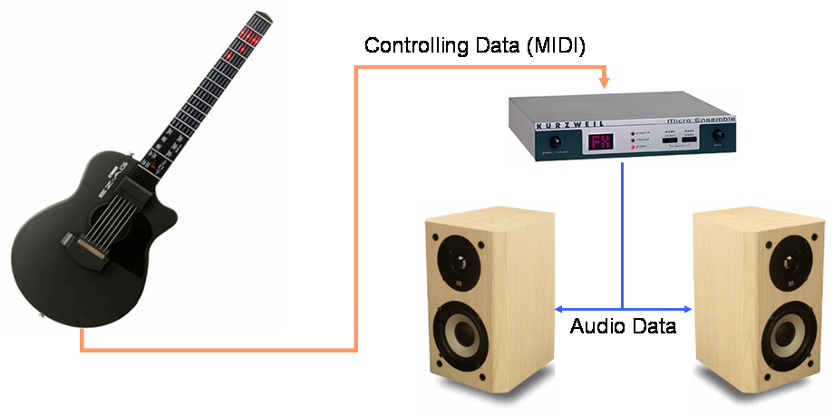
Figure 9: Typical MIDI setup.

The communication protocol must guarantee that the musical information generated in the controller will be understood by the sound generator unit, so it can render the note, no matter which instrument was used to generate the musical information. Instruments have their own way to be played and different performance techniques are subjective to the instrumentalist, so how is it possible to have standardization to all instruments? It isn’t. The MIDI was designed for keyboard-like instruments and this simplification costs the expressiveness of the performers which main instrument is not keyboard-like, for instance the guitarists. This fact also forces the sequencers to treat musical material identically;
The question is: how the Octopus Music API deals with this problem? First, its important have in mind that Octopus API does not aim to be a synthesizer or a communication protocol, but just a bridge between musical software and synthesizer. Normally, the musical software would make a direct use of the protocol through its language libraries. This API can be seen as another layer placed between the musical software and the communication protocol. In other end of link there is the synthesizer that must support the protocol. There isn’t a commercial synthesizer designed for this expressive control in particular instruments because, once again, they are limited to the communication protocol standardization. So, what communication protocol should be used in the Octopus API to communicate with a synthesizer that doesn’t even exist?
The solution found was creating a middle-tier protocol able the carry all the non-structure data relating to the music performance of a particular instrument. A possible solution should be the adoption of a XML format, but it was tried to keep it simple avoiding the use of XML Parsers APIs.

Class octopus.communication.MusicalEvent
What a synthesizer should know about guitar music performance? Is it the same knowledge for a saxophone performance? A subset of actions might be the same, but not all. Whatever these actions are it is always true that happen along the time. That’s what a musical event is to this API.
Musical event is an action related to the music performance that happens in a certain time. These actions usually is related to the production of a sound, but the parameters or sub actions involved in this major activity varies from instrument to instrument and also from the capability of the synthesiser to recognise it. For instance, suppose that the shape and the hardness of the pick were parameters that a XYZ guitar synthesizer used to render the sound. Maybe, for another guitar’s synthesizer this information is not relevant, but region where the string was attacked is. Basically, this example show us that the performer needs freedom to interact with his instrument in any way that is possible to generate sound, even non-traditional ways.
To deal with all this possibilities, the Class MusicalEvent extends the java.util.Properties. Basically is a collection of attributes and values. To make it simple, usually all the values are Strings but this is a vendor implementation decision.
Since some parameters appear quite often, it was decided to make them permanent class attributes. They are: note, duration, timing and velocity

Class octopus.communication.MusicalEventSequence
A simple MusicEvent is not more than one note. If it is necessary write down a whole music you probably going to need more than one MusicalEvent, expect if you are John Cage. The MusicalEventSequence is a sequence of MusicalEvent in a row. Its is also a interesting way to group musical event and process them all together, like when you want to delay all the events of a sequence in certain amount of time or speed the music.
A MusicalEventSequence is the object that the Musician generates when they are requested to play something, because who actually “plays” the music is the synthesizer through the SynthesizerController.

Class octopus.communication.SynthesizerController
The abstract class SynthesizerController is a parser from the MusicalEventSequence to whatever protocol is used to control the synthesizer. The current standard protocol support by the synthesizer is still MIDI, so this API brings a SynthesizerController that parse MusicalEvent into MIDI messages.
The MidiSynthesizerController are able to communicate with external devices through the MIDI ports. This is done connecting multiple receivers to its transmitter.
As the guitar is the main instrument in this API at this point, a special MidiSynthesizerController was designed to convert guitar performance information into MIDI system exclusive messages. Actually, these messages vary according to the device that is receiving it. For instance, a SysExMessage to flash a fret’s position in the Yamaha EZ AG MIDI controller is different from a message to do the same job in a controller from another manufacture. This means, the Class OctopusReceiver must be specialized to convert a guitar’s performance action into the correspondent SysExMsg supported by the device.
In a guitar context, two receivers were implemented: GraphicalGuitarMidiReceiver and YamahaEzAgReceiver. The first control the GuitarGraphicalInterface giving visual feed-back to the user through a guitar like graphical interface and the second one generates SysExMessages to the YAMAHA EZ MIDI guitar controller.

References
- Hornbostel-Sachs. System of musical instrument classification, 1914.

- COSTALONGA, L., VICARI, R. Multiagent System for Guitar Rhythm Simulation , IIIS - CCCT 04, Austin-Texas -USA; Agosto 2004;

- COSTALONGA, L.; MIRANDA, E.; MATTHIAS, J., VICARI, R. An Idiomatic Plucked String Player. In: Proc. of FLAIR’s Special Track on Artificial Intelligence in Music and Art, 2006, Melbourne, Florida, USA.

Commom Music Notation

